Claude Lieber, MS, MD, FACS

Solution of Predator/Prey model

Modified: 12/22/2022
clear
clc
close all
System of equations (predator/prey model - Slide 51 in PowerPoint where we saw system to be oscillatory)
dx/dt= 0.2x-0.25xy
dy/dt= -0.1y+0.02xy
syms x y % defines symbolic variables
dxdt= 0.2*x-0.025*x*y; %Predatory/Prey equations
dydt= -0.1*y+0.02*x*y;

Next, find the equilibrium points of the set of differential equations. This occurs when all three differential equations equal zero.
EqPts=solve(dxdt==0,dydt==0);
fprintf('The equilibrium points are:\n');fprintf('[Prey,Predator]\n');disp([EqPts.x(1,1),EqPts.y(1,1)]);disp([EqPts.x(2,1),EqPts.y(2,1)])
The equilibrium points are:
[Prey,Predator]
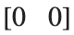
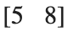
Next, we linearize the system to determine whether the system is stable at each equilibrium point
eqns=[dxdt,dydt];
J = jacobian(eqns);

J1=subs(J,[x,y],[EqPts.x(1),EqPts.y(1)]);% substitutes values for x and y
J2=subs(J,[x,y],[EqPts.x(2),EqPts.y(2)]);
Now print output:
fprintf('The equilibrium points are:\n');fprintf('[Prey,Predator]\n');disp([EqPts.x(1,1),EqPts.y(1,1)]);disp([EqPts.x(2,1),EqPts.y(2,1)])
The equilibrium points are:
[Prey,Predator]


fprintf('The Jacobian of this system is:\n');disp(J)
The Jacobian of this system is:
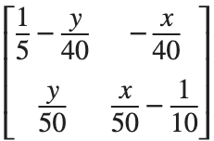

fprintf('For Eq. Pt. (%3.2f,%3.2f)\n ',EqPts.x(1,1),EqPts.y(1,1));fprintf('The Jacobian is:\n');disp(J1)
For Eq. Pt. (0.00,0.00)
The Jacobian is:
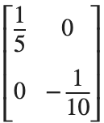
fprintf('Whose eigenvalues are: \n');disp(eig(J1))
Whose eigenvalues are:
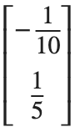
Since both eigenvalues are real and one of them is positive, the system is unstable at this equilibrium point. From the formulas, we can see that if there are no predators nor prey, but if prey is introduced (even a very small number of prey), the number of the prey will increase exponentially in the absence of predators. Therefore, the equilibrium point, (0,0) is unstable, i.e., a small perturbation from that point will lead to the system leaving that point permanently.
fprintf('For Eq. Pt. (%3.2f,%3.2f)\n ',EqPts.x(2,1),EqPts.y(2,1));fprintf('The Jacobian is:\n');disp(J2)
For Eq. Pt. (5.00,8.00)
The Jacobian is:
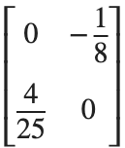
fprintf('Whose eigenvalues are: \n');disp(eig(J2));
Whose eigenvalues are:
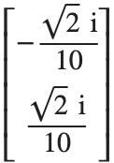
The eigenvalues have no real parts, only imaginary parts. This makes the equilibrium point a "center." In other words, the system oscillates.

To solve this system of differential equations, we need to tell Matlab that these equations are differential functions dependent on time:
syms x(t) y(t); % now Matlab knows that time is the independant variable
F = diff(x,t) == 0.2*x-0.025*x*y; % Defines F as a differential eq. of time, dx/dt
G = diff(y,t) == -0.1*y+0.02*x*y; % Defines G as a differential eq. of time, dy/dt
To ask Matlab to solve this system of differential eq. we use the dsolve() command
Solution=dsolve(F,G) % we see that an explicit solution does not exist, so a
% numerical solution (aproximation) is necessary
Warning: Unable to find symbolic solution.

Solution =

[ empty sym ]

